**TASK 1 – LAUNCH YOUR OWN LINUX EC2 INSTANCE**

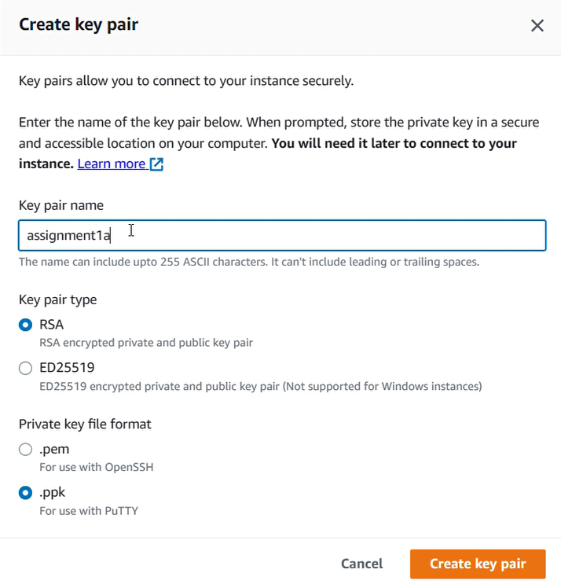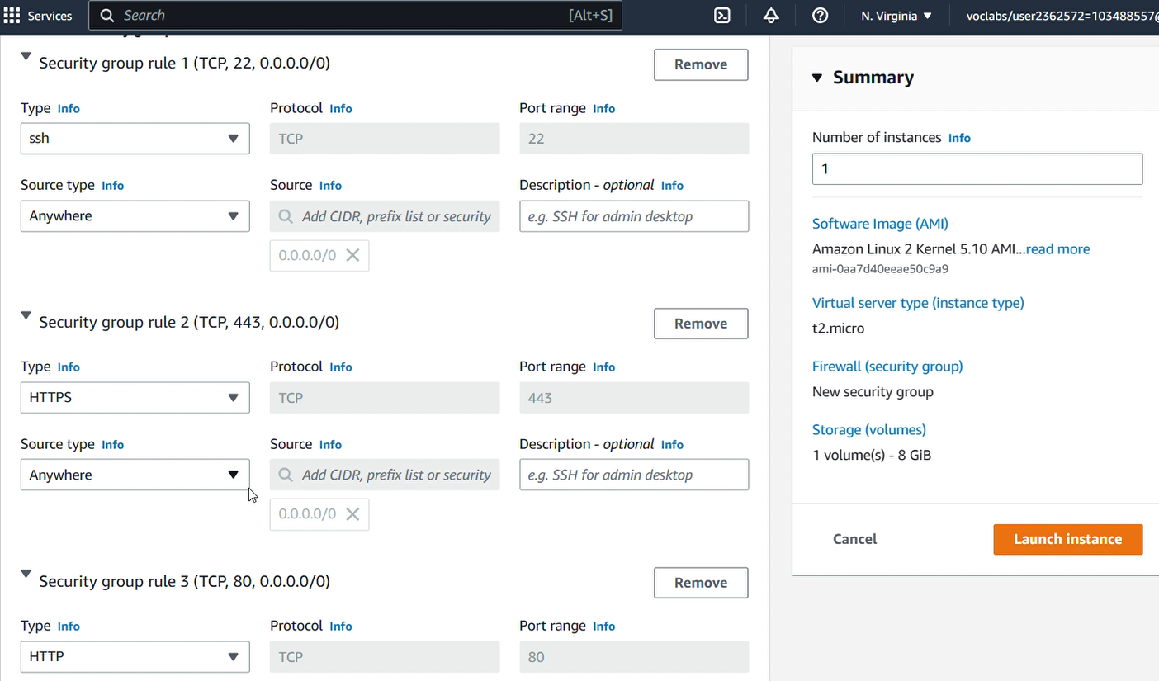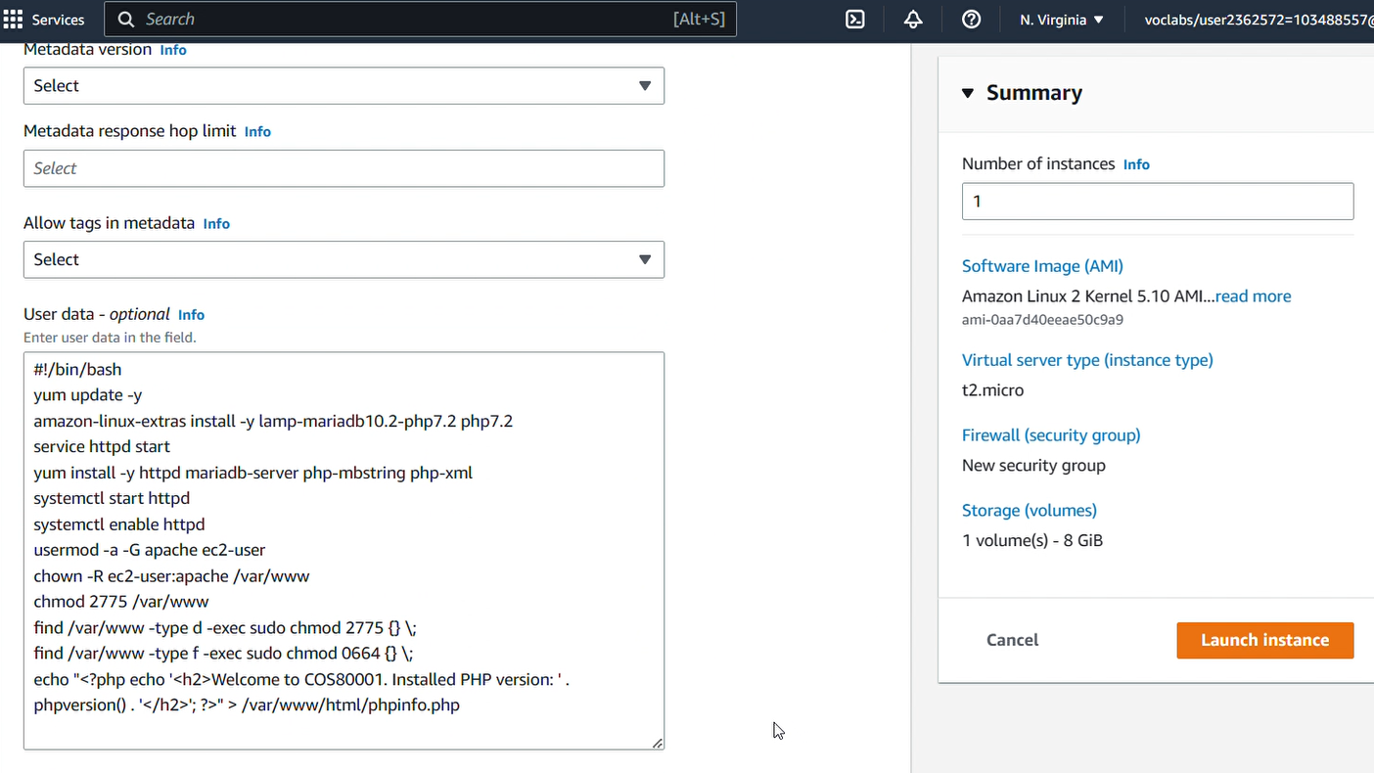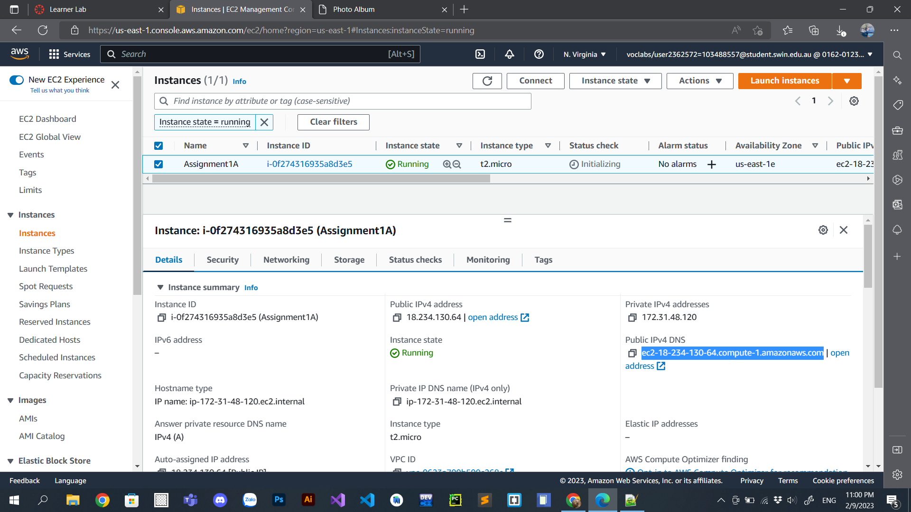

**TASK 2 – CREATE A PHP WEBSITE (PHOTO ALBUM)**

**PuTTY setup**

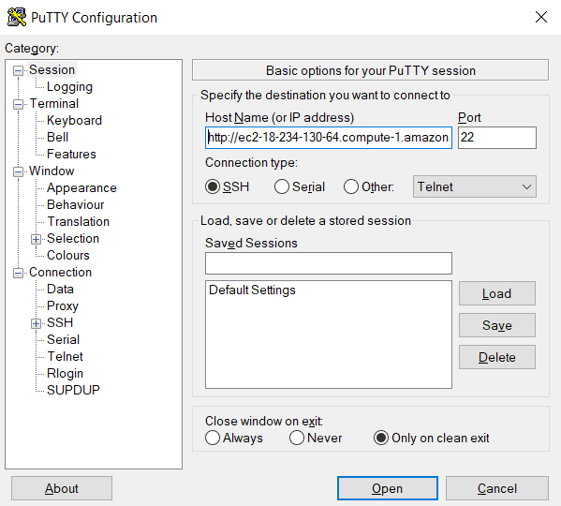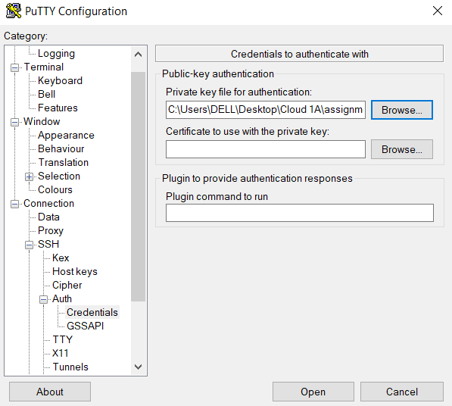

Public IPv4 DNS

.ppk file created in the **Instance Launch – Key pair** section.

**WinSCP setup**

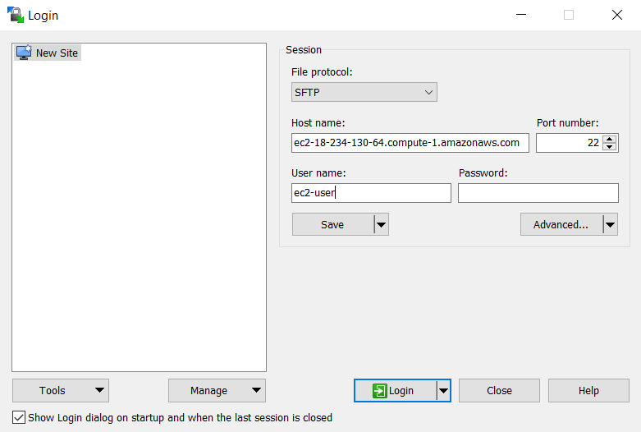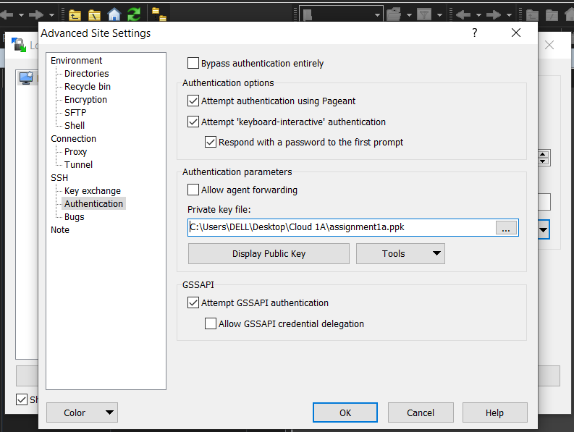

1. Public IPv4 DNS

.ppk file created in the **Instance Launch – Key pair** section.

2. Click **Advanced** > **Authentication** > browse the **.ppk** file

3. Login

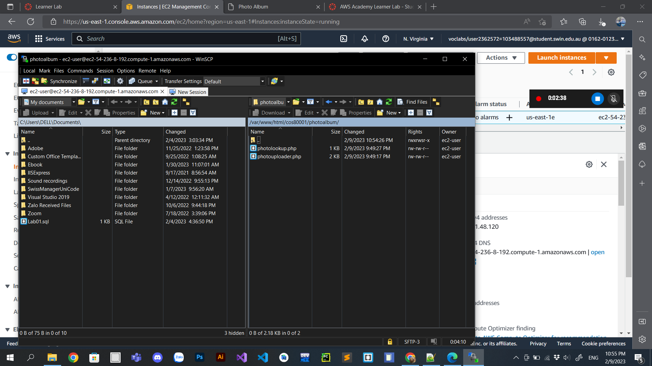

Put two PHP files in the correct directory.

**FINAL RESULT (2 PHP files are correctly displayed on the browser)**

